**Payroll Management System**

(Payroll-Central)

* **Introduction:**

A payroll management system is a software application that automates the process of calculating and paying employee salaries. It typically involves keeping track of employee hours worked, calculating taxes and deductions, and generating pay checks. Payroll management systems can save businesses time and money by eliminating the need for manual calculations and processing.

This project will develop a payroll management system for a small business. The system will be designed to be easy to use and affordable. It will also be scalable so that it can be used by businesses of all sizes

The system will include the following features:

* Employee management: The system will allow users to create and manage employee records, including name, email address, residential details, contact information, job title, hire date and salary
* Payroll calculation: The system will automatically calculate employee wages, considering overtime, bonuses, and deductions.
* Tax withholding: The system will withhold the appropriate taxes from employee pay checks, in accordance with the law.
* Pay check issuance: The system will generate pay checks for employees and distribute them via direct deposit or paper check.
* Reporting: The system will generate reports on payroll data, such as hours worked, wages paid, and taxes withheld.
* **Objectives:**

The System main objectives are as follows:

* To develop a user-friendly and efficient payroll management system that automates the process of calculating and disbursing employee salaries, bonuses, and deductions.
* To ensure compliance with all relevant tax laws and regulations.
* To provide accurate and timely payroll reports to management.
* To improve the efficiency of the HR department by freeing up time to focus on other tasks.
* To improve employee satisfaction by ensuring that they are paid accurately and on time.
* **Modules:**

The system comprises of 2 major modules with their sub-modules as follows:

1. Admin:
2. Login: Admin can login into system.
3. Add Employee: Admin can add employee.
4. Employee Details: Admin can view all employee details.
5. Change Details: Admin can change the details of employees.
6. Change Status: Admin can change the status of the employee.
7. Generate Payroll: Admin can generate payslip for employees
8. Employee:
9. Login: Employee can login in his profile.
10. Profile: Employee view his profile details.
11. Change Details: Employee can change his limited details.
12. Generate Payroll: Employee can generate payslip for themselves.

* **Software Requirements:**

Follows are the Software requirements of the project:

* Windows 7 or higher
* MongoDBCompass
* NodeJs
* Visual Studio Code
* Google Crome
* **Technology:**

The Technology which is used for the project is as follows:

* **Fronted:**
* ReactJS
* Tailwind CSS
* Material UI
* **Backend:**
  + NodeJs
  + Express
  + MongoDB
  + Mongoose
* **Hardware Requirement:**

Follows are the Software requirements of the project:

* + Processor: Intel Core i5
  + SSD: 512GB
  + RAM: 8GB

* **Advantages:**

This are the advantages of our project:

* Easy to use.
* It is completely secure.
* It is completely controlled by admin.
* This system is easily compatible with most of the web browsers.
* It is very interactive and saves time.
* Reduces paper works.
* Calculations are automated so it is highly accurate.
* Admin can view all the records whenever necessary with ease.
* **Flow Chart:**

1. Admin

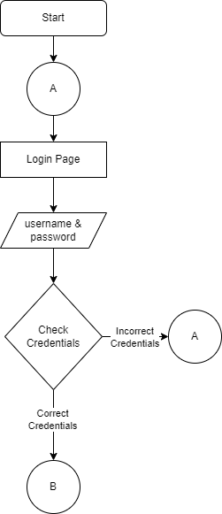

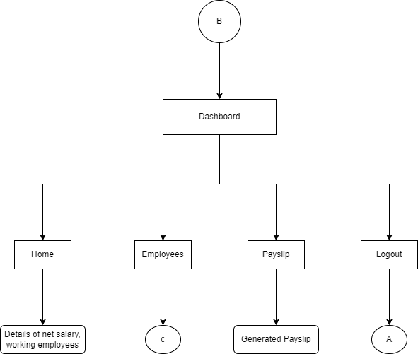

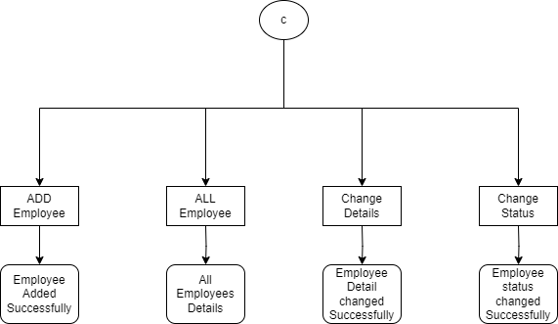

1. Employee:



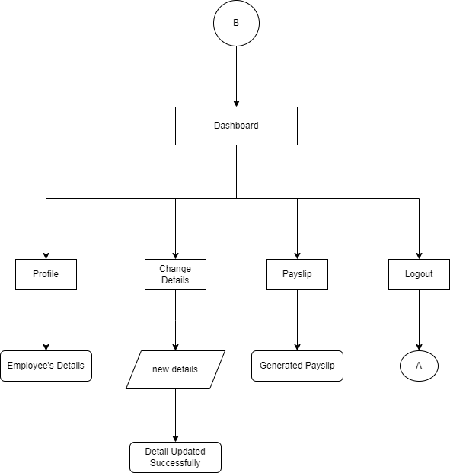

* **ERD:**

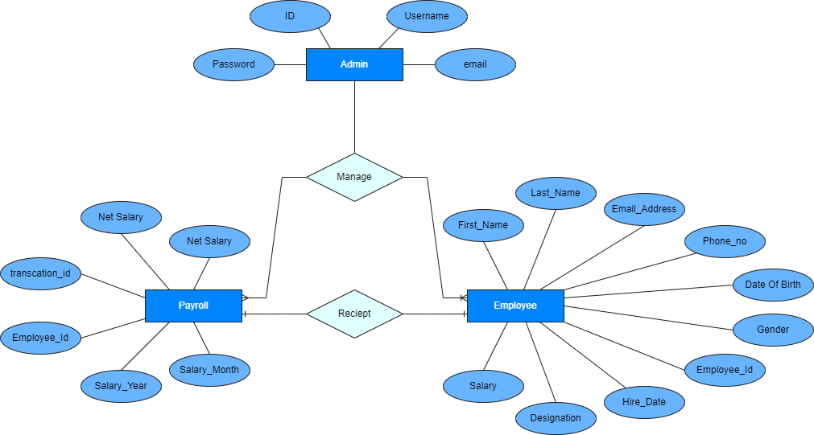

* **Input Screenshot:**

1. Login page:

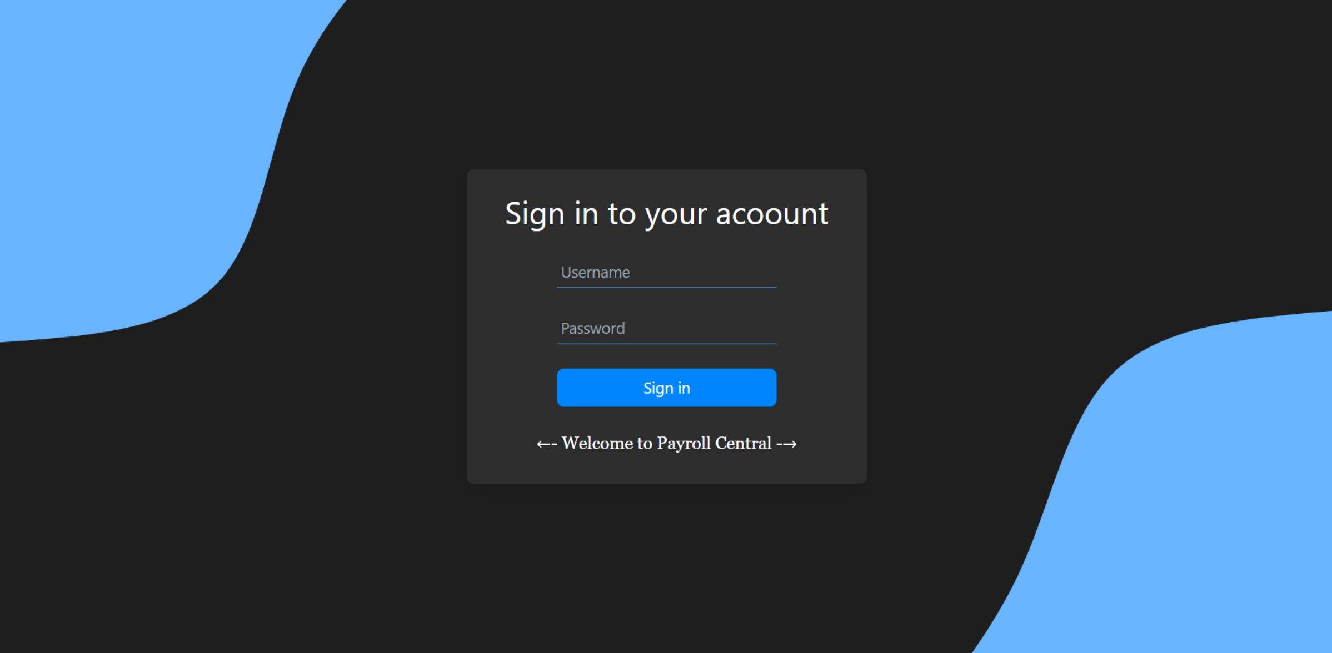

1. Add Employee Form:

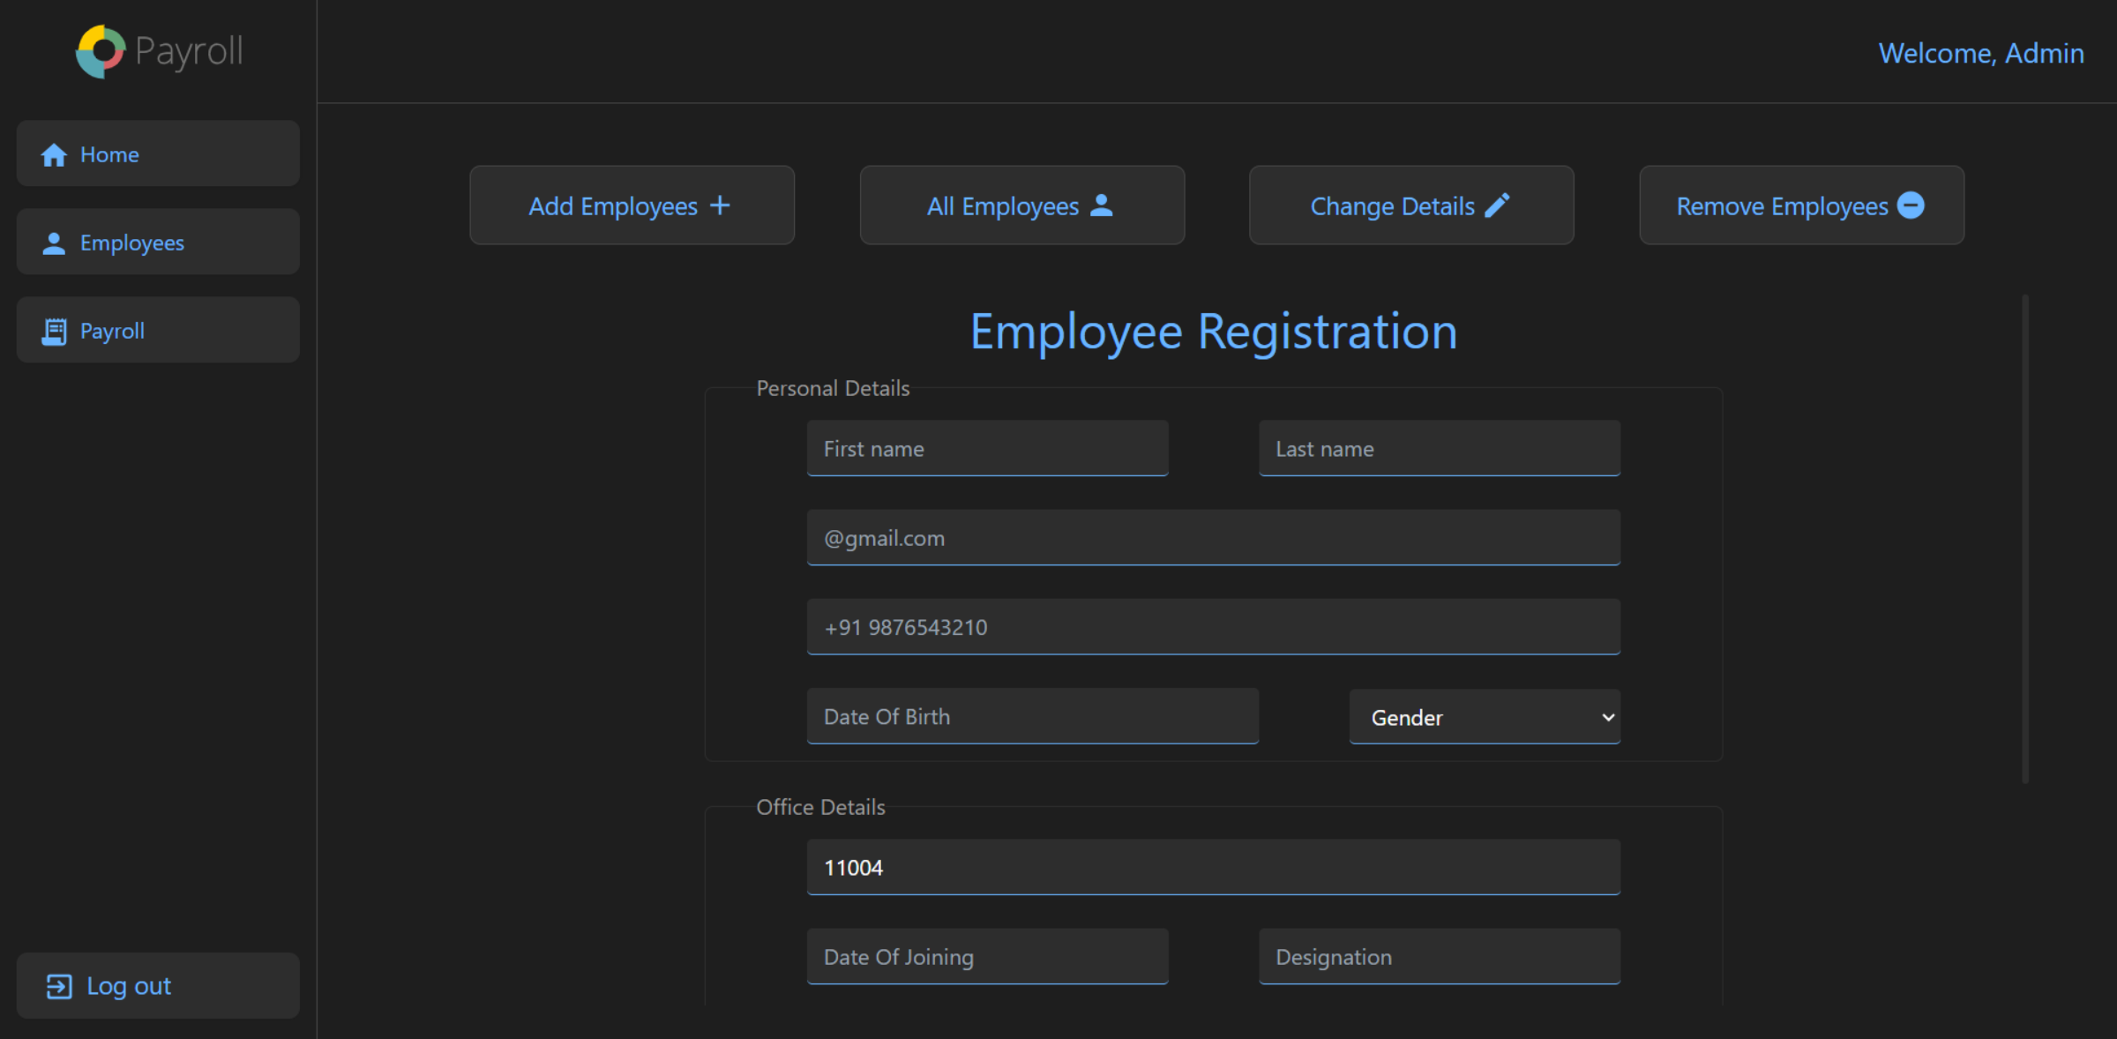

1. Change Details Form:

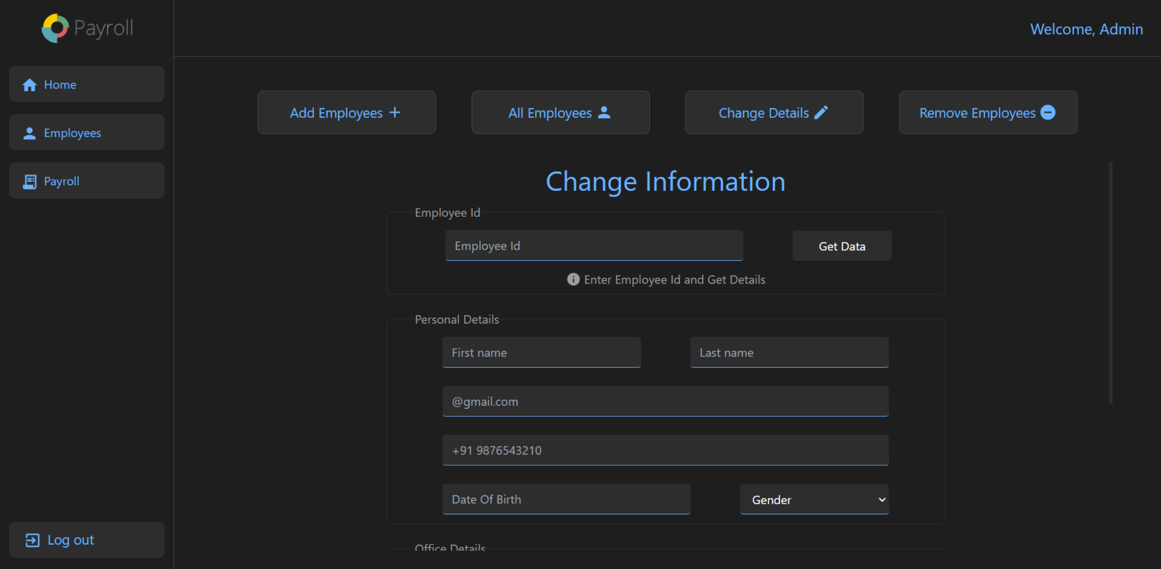

1. Change Status Form:

